A REPORT ON THE ALL-AFRICA PERSONS WITH DISABILITIES (PWD) ARTS AND TALENT SHOW, WHICH HELD FROM NOVEMBER 30th TO DECEMBER 2, 2024 IN ABUJA, NIGERIA
INTRODUCTION
The all-Africa PWD arts and talent show took place at the Exclusive Serene Hotel Abuja from the 30th of November to the 2nd of December, 2024. The main organizers were the Joint National Association of Persons with Disabilities in Nigeria (JONAPWD) and the Seams Deaf-Pro Foundation based in Lagos, Nigeria. The aim of the talent show was to encourage the development of talents amongst PWDs from across Africa and to enhance unity amongst them. The physical participants came from Ghana, Lagos and other states of Nigeria and Cameroon while those from other African countries like Chad, Niger, Togo, Benin etc participated virtually due limited logistics.
Cameroon was fully represented by the Disability Rehabilitation and Life Animation (DRELA), a disability rights advocacy organization, based in Buea. The DRELA delegation was made up of five members led by Dr Charly R. Nyugap, its Executive President. The other four members were Mrs Nyuydine Jacqueline Banfogha, Pastor Paul Nsakor Bamnjo, Mr Fon Francis, and Madam Ngong Grace Kieleh. This group showcased talents in traditional music. They left Cameroon on the 28th of November 2024 and traveled by road to Abuja through the Ekok Nfum boarder and passed the night at Ikom, a boarder town in Cross River State. They finally arrived Abuja at 10 pm on the 29th of November 2024, carrying musical instruments from Cameroon.
PRE-FESTIVAL ACTIVITIES
In the afternoon of Sunday December1st, the treasurer of the Cameroon High Commission, Mr. Lukong Terence and his wife, hosted the DRELA delegation at their residence after which the DRELA delegation visited the Panso people in their monthly meeting in Abuja. The Panso people, who come from Taraba state, Nigeria are the Nso people who settled in Taraba State, before the plebiscite of 1961. When British Southern Cameroon voted in the plebiscite to reunify with the Republic of Cameroon (former French Cameroon), they remained in Nigeria and today constitute a bonafide ethnic group in the country.
FESTIVAL ACTIVITIES
The first two days of the show were characterized by rehearsals and exhibition of works of art while the third day was the grand finale, marked by the presentations and award of prizes. The grand finale on the 2nd of December 2024 started at 1:40pm with a welcome speech presented by Mr. James Samuel, the Executive Director of Seams Deaf Pro-Foundation in which he welcomed everyone to the third edition of the talent show, which he described as the first of its kind because it involved all categories of persons with disabilities. The idea of the show as conceived by Mr. James Samuel, ED of Seams Deaf Pro-Foundation only focused on persons with hearing impairment. This is why the 1st edition which took place in Lagos where the organization is based and the second in Ghana involved only persons with hearing impairment. This time around, they thought it necessary to include other categories of disabilities. Mr. Ayo, representing the president of JONAPWD who was unavoidably absent also presented a speech in which he appreciated everyone for bridging all gaps to participate in the event, and called on all PWDs to break the barriers in order for society to see and promote the enormous talents they possess as there is ability in disability.
At this juncture, the various groups participating in the event were given the floor to showcase their talents. Most of the presentations were done by Nigerian based groups from the different states of the federation. DRELA, the organization that represented Cameroon presented a traditional dance from the western grassland of the country, using traditional musical instruments like the drums, gong, rattle, traditional trumpet, and putting on the traditional attire from the region. The group became a point of attraction as they were the only ones who thought of using traditional costumes. Their peculiar dressing and the melody in their songs caused everyone in the hall to start asking to know which country was presenting.
During the performance by DRELA, its Executive President wore the national flag of Cameroon, collected from the office of the Cultural Attaché in the Cameroon High Commission, Abuja, as a sign of patriotism, and also to indicate the country’s determination to promote disability inclusion. The DRELA Executive President (EP) was also given the opportunity to make a speech in which he indicated that Cameroon is participating in such an event for the first time. In his speech, he appreciated and called on Nigeria to increase her “Big Brother role” by always pulling Cameroon and other African countries along in their many initiatives and endeavours to promote disability inclusion. The wife of the treasurer, at the Cameroon High Commission Mrs. Lukong Kelen came with a couple of individuals from the mission to chair up and offer DRELA moral support.
Other groups equally showcased different talents. These included ballet dances by persons with hearing impairments from Nigeria and Ghana, and poems by persons with visual impairment from Nigeria, drawings, paintings and other works of art by persons with hearing and physical impairments. It is worth noting that Master of Ceremony (MC) of the event was a lady with visual impairment from Nigeria. It is a policy in Nigeria that the MC of every event related to disability inclusion must be a PWD.
One of the remarkable things done by the organizers of this event was the printing of T-Shirts for participants. The T-shirts produced for participants form each country had the map and national flag of their country on it. The occasion ended with refreshments and interview sessions by the Nigerian Television Authority (NTA) and other press organs that were present. The NTA came for an interview with the DRELA Executive President. This was followed by snap shots of the organizers with DRELA to immortalize the event.
POST FESTIVAL ACTIVITIES
Celebration of International Disability Day
During this trip to Nigeria, the DRELA Executive President lobbied for the organization to take part in the celebrations of the International Disability Day in Abuja, which was organized by the Nigerian National Commission for Persons with Disabilities. In response to this request, DRELA was invited to participate on the 3rd of December 2024, in the activities marking the national celebration which took place at the Congress Hall of the Transcorp Hilton Hotel, Abuja. The occasion was attended by officials of Nigerian Government ministries, departments and agencies, representatives of Diplomatic missions, and international humanitarian development organizations.
The Nigerian government officials in their good will messages, each presented their disability inclusion score card by explaining the policies they are been put in place to employ PWDs and create a disability friendly environment. The representatives of diplomatic missions commended Nigeria for her giant strides in the area of disability inclusion and pledged their support to the country in this domain. The international humanitarian development partners like Sight Savers and Christian Blinden Mission equally presented goodwill messages.
DRELA was also exceptionally granted an opportunity to present a goodwill message although it was not part of the initial plan. Its Executive President who spoke, revealed the efforts being made by Cameroon Government in the area of disability inclusive development, and called on partnership from the Nigerian state, organizations and individuals. There was also a Panel discussion on Building Cross-Sector Partnerships for Disability Inclusion during the event.
DRELA had snap shots with some of the dignitaries including the Senior Special Assistant to the Nigerian President on Special Needs and Equal Opportunities, and the Executive Secretary of the Nigerian National Commission for PWDs. The Executive Secretary of DRELA also granted and interview on the participation of Cameroon and the significance of the celebration, to Africa Independent Television(AIT), a popular Nigerian Television Station which broadcast across the globe.
Visit to Cameroon High Commission
On the 4th of December 2024, DRELA Délégation visited the Cameroon High Commission in Nigeria. The Cultural Attaché and the High Commissioner, Prof. Perpetua Lola and Salaheddine Abbas Ibrahimma respectively. Prof. Perpetua Lola provided a warm welcome and appreciated the courtesy call paid to her office each time the DRELA Executive President visits Nigeria, and commended him for being the voice of PWDs back in Cameroon. She advised DRELA to use the media to inform Cameroonians on its experiences at the festivals. She added that she will include DRELA’s participation in the events in her Report to the government of Cameroon. She then led the DRELA delegates to the High Commissioner’s office.
The High Commissioner expressed gratitude to the organization for always paying a courtesy call to the High Commission each time it comes for an event to Nigeria. He commended members of the delegation for being resilient and using their talents to promote the image of the country. He requested an official report from DRELA to submit to the government, just as was the case in 2023 when the organization went to observe the general elections in Nigeria.
Return Trip
The DRELA delegation left Abuja on Thursday the 5th of December 2024 and passed a night at Ikom. They used Friday the 6th to purchase some items for their families with the intention of leaving for Cameroon the following day but news of insecurity along the Bamenda-Ekok road caused them to finally leave Ikom on Sunday the 8th of December 2024 for Cameroon. They finally arrived their various homes in the evening of that day, except Ngong Grace who only arrived her home on the 10th, two days later due to Ghost town operations on Monday the 9th of December,2024.

SIGNIFICANCE OF THE FESTIVAL.
This festival offered participants the chance to enhance their artistic talents through workshops, masterclasses, and exposure on international platforms. It fostered networking with artists, mentors, and industry professionals creating pathways for career growth in the arts and entertainment sectors.
Participants also gained confidence through performances, recognition, and access to top-tier resources and mentorship.
The program encouraged cultural exchange and offered inspiration through the success stories of other PWD artists.
It also enhanced public awareness of the abilities of PWDs and promoted their representation in arts and media.
Community bonds were strengthened across Africa, fostering solidarity and collaboration.
The platform enabled advocacy through creative expression, giving voice to disability-related issues.
By challenging stereotypes, it contributed to changing public perceptions.
Overall, the festival motivated more PWDs to explore and embrace their creative potentials.
DRELA’s trip to Abuja fell within the context of Cultural Diplomacy between African countries. The festival was an opportunity for organizations from participating states to use cultural instruments such as music, poetry, and fine arts (painting and sculpture) to promote mutual understanding and cooperation.
DRELA as an organization representing Cameroon was able to create a relationship with the Disability Rights Advocacy Organization which represented Nigeria and Ghana at the event. In terms of People-to-People Diplomacy, on the way to Nigeria and back, we interacted with transporters, Hotel workers, Business people, and security officers. This further enhanced relations between the citizens of both countries and by extension relations between the states. During the trip, we had exchanges with the Nigerian government officials and those of International Humanitarian Development Organizations operating in Nigeria.

CHALLENGES OF THE TRIP

Despite the benefits and achievements, the trip was not without constraints;
we faced financial and security challenges, given that there is an ongoing war in the Anglophone regions. DRELA did not get sufficient responses to the appeal letters she sent out. As PWDs, we had to travel by road through the conflict zone (Conflict in the Anglophone region of Cameroon). On our way back we had to stay in Ikome for about 2-3 days because the road from Bamenda to Ekok was blocked by armed forces (separatist fighters).
Negative attitudes from the members of the public who, whether as a result of ignorance or superstition, still hold very uneducated ideas about disability. It was also very challenging to move without a sighted guide.
CONCLUSION
On the whole, the trip to attend and participate in the All African PWDs Arts Festival was a memorable one. The Arts festival, the celebration of International Disability Day, the audience at the Cameroon High Commission and just traveling to and from Nigeria were experiences that greatly expanded our horizons. It is important to note here that at least two members of our delegation were traveling out of Cameroon for the first time. This trip was a unique opportunity, not only to showcase the ability in Disability but also to display the resilient spirit that drives
PWDs. The inability of our sighted guide, Dr. Shu Emmanuel Ngwa to travel with us did not in any way dampen our morale. Paradoxically, our leader Dr. Charly Ringnyu Nyugap summoned exceptional courage as a person with Visual impairment to lead a traditional dance group of three persons with Visual Impairment to and from Nigeria.

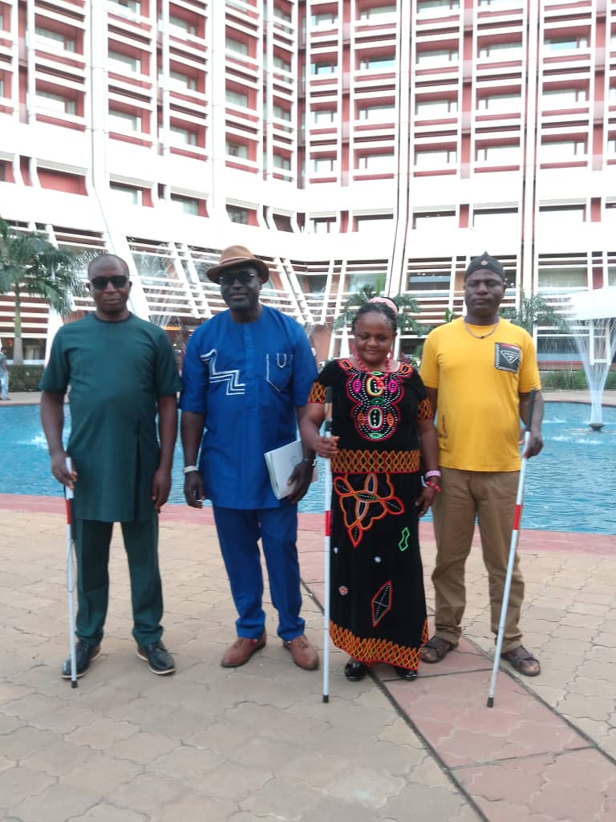DRELA DELEGATION TO THE ALL AFRICA PERSONS WITH DISABILITIES ARTS FESTIVAL,ABUJA 2024
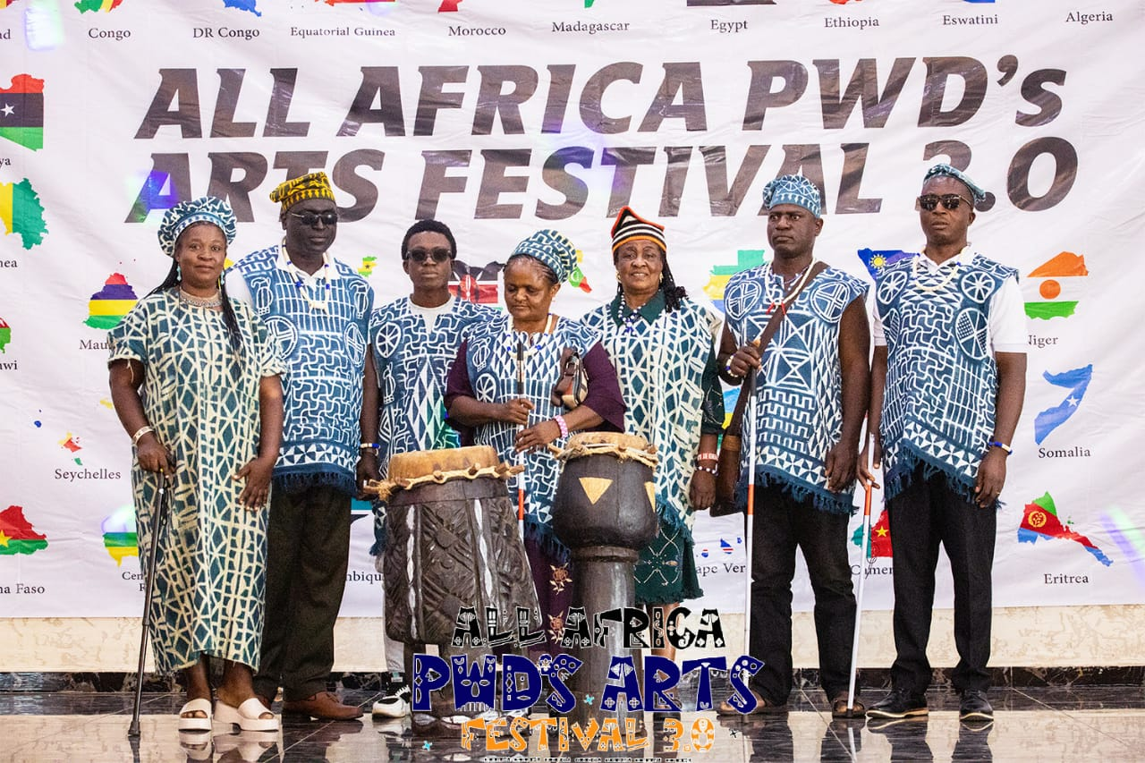
DRELA TRADITIONAL DANCE GROUP AT ALL AFRICA ARTS FESTIVAL

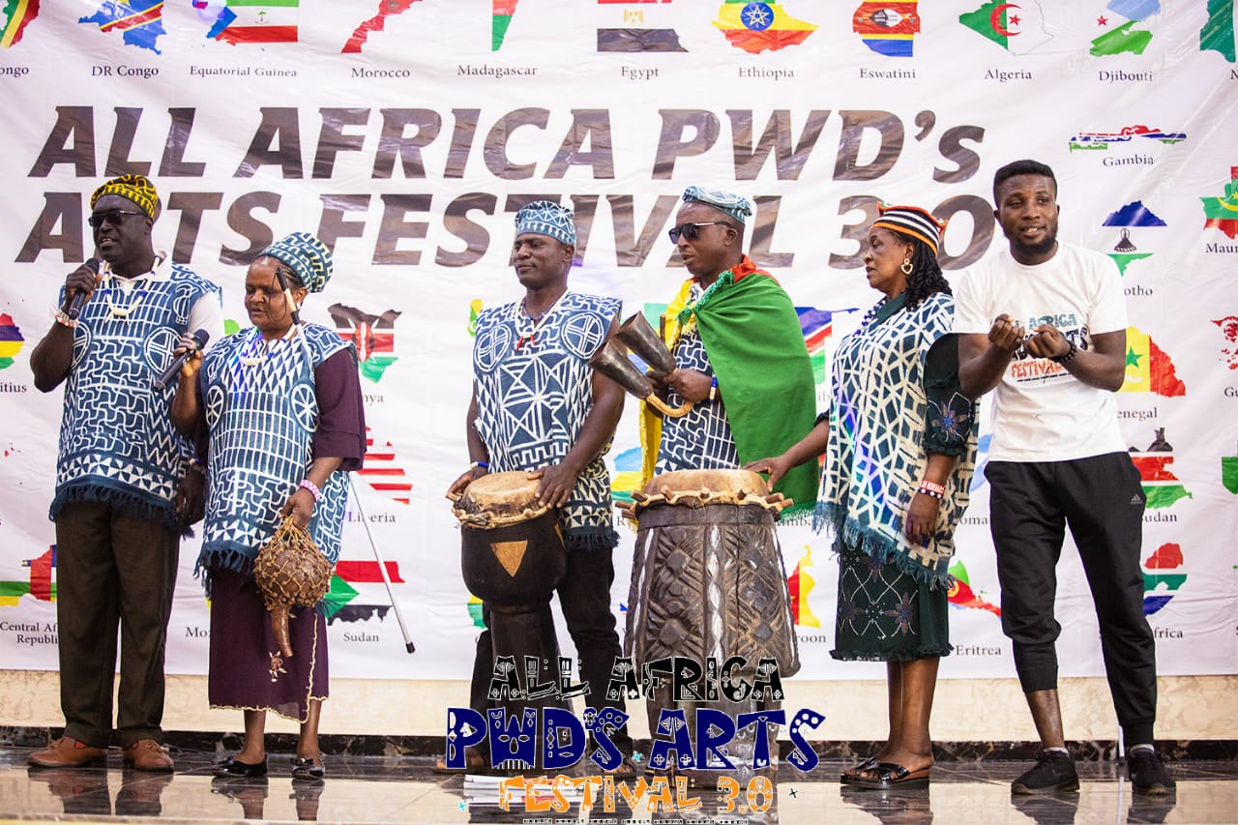
DRELA TRADITIONAL GROUP ON STAGE
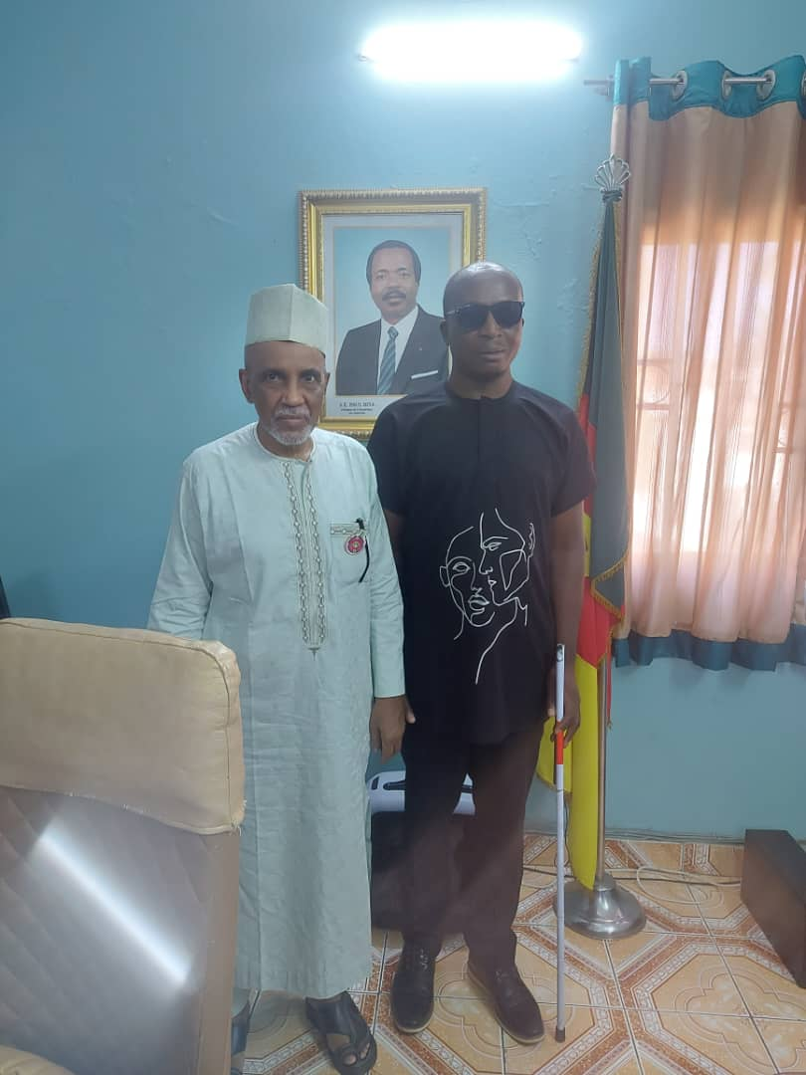
DRELA TEAM LEADER WITH CAMEROON HIGH COMMISSIONER, ABUJA
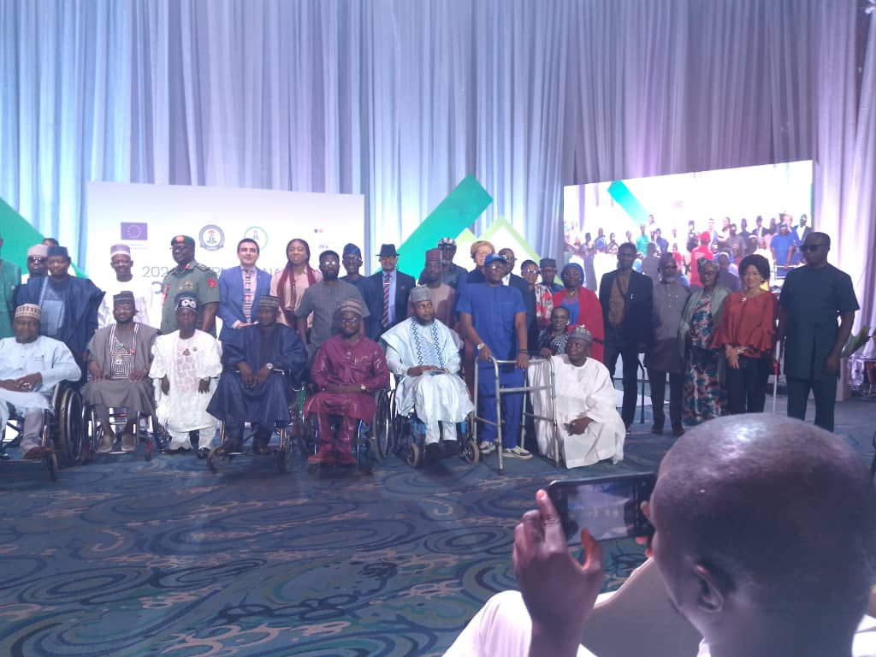
GROUP PICTURE ON INTERNATIONAL DISABILITY DAY
GOVERNMENT OFFICIAL, DIPLOMATS ETC.

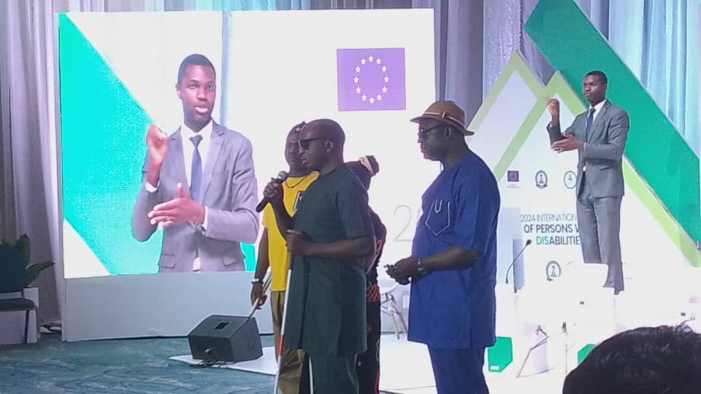
LEADER OF DRELA DELEGATION PRESENTING GOOD WILL MESSAGE ON INTERNATIONAL DISABILITY DAY, ABUJA 2024

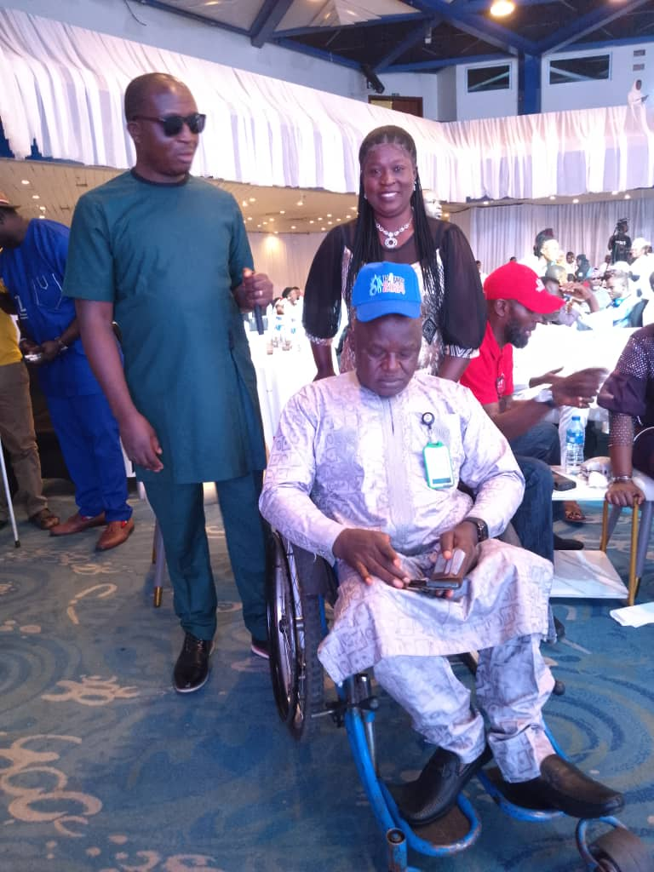
DRELA TEAM WITH BARRISTER AYUBA GOFWAN, EXECUTIVE SECRETARY, NIGERIA NATIONAL COMMISSION FOR PERSONS WITH DISABILITIES

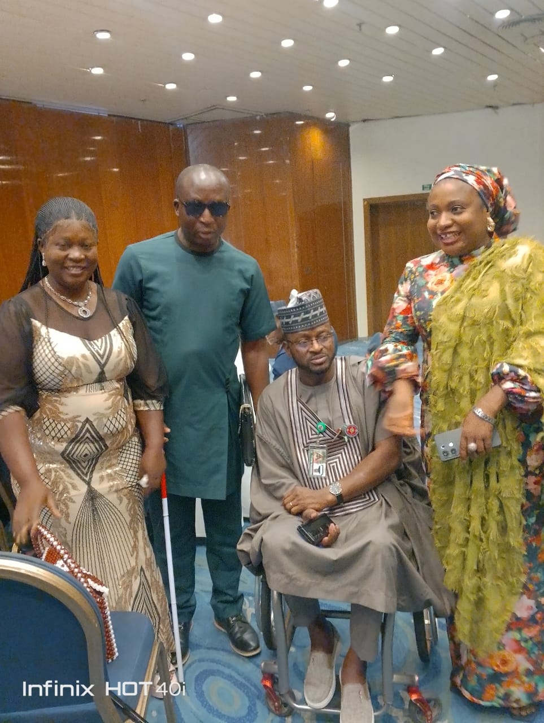
DRELA TEAM WITH HON MOHAMMED ABBA ISSA, SENIOR SPECIAL ASSISTANT TO NIGERIAN PRESIDENT ON SPECIAL NEEDS AND EQUAL OPPORTUNITIES
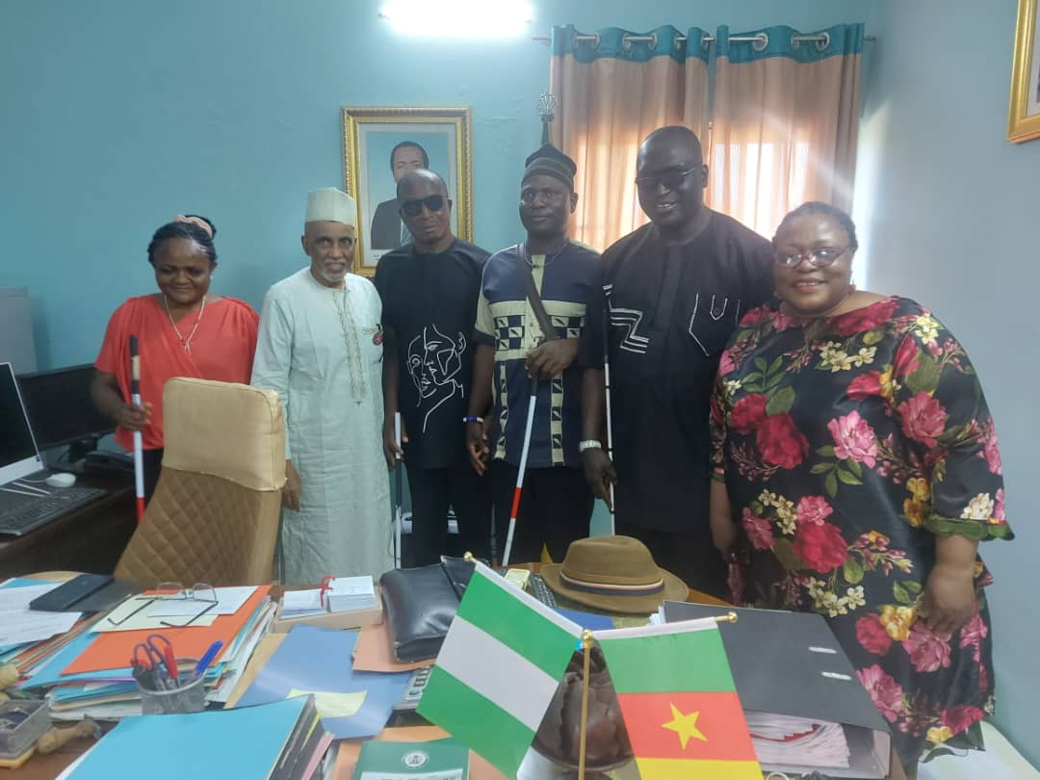
DRELA DELEGATION WITH CAMEROON HIGH COMMISSIONER AND CULTURAL ATTACHE IN ABUJA OFFICE
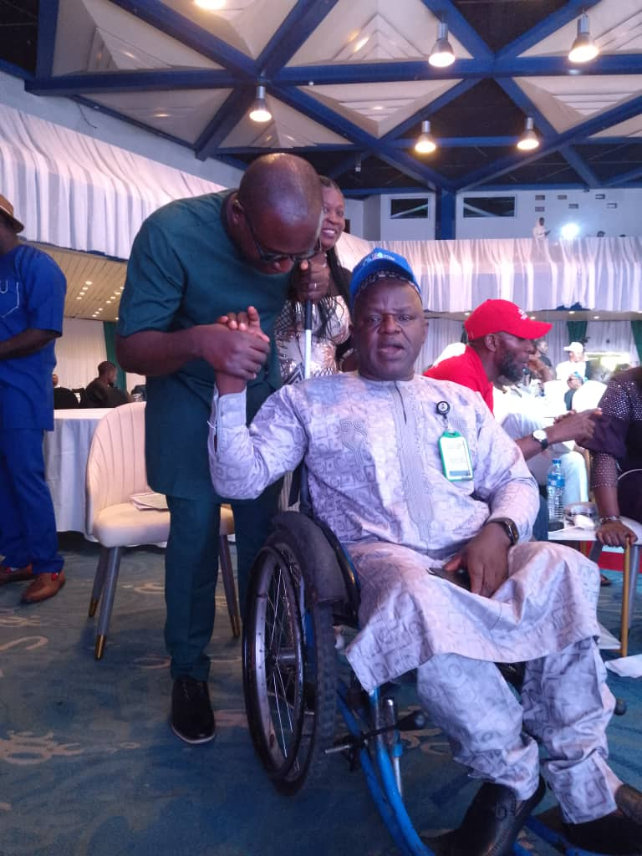
DR CHARLY NYUGAP WITH BARRISTER AYUBA GOFWAN EXECUTUVE SECRETARY, NCPs
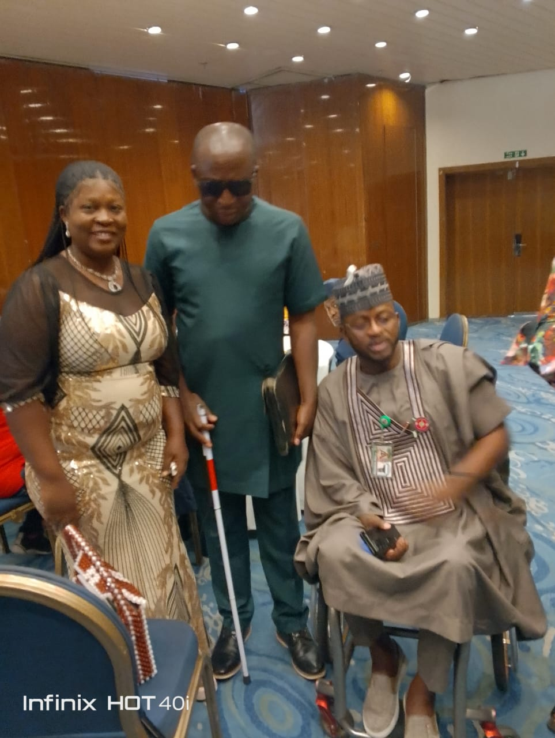
DR CHARLY NYUGAP WITH HONORABLE MOHAMMED ABBA ISSA, SPA TO NIGERIAN PRESIDENT.

