A REPORT ON DRELA’S MISSION TO OBSERVE NIGERIA'S PRESIDENTIAL AND NATIONAL ASSEMBLY ELECTIONS WHICH TOOK PLACE ON 25TH FEBRUARY 2023.

Submitted to:

The Nigerian Consul General,
Buea, Cameroon

By:
Dr. Charly Ringnyu Nyugap
Department of Educational Psychology
Faculty of Education
University of Buea, Cameroon

&
Executive President/CEO
DRELA, Buea, Cameroon

DRELA’S REPORT ON INTERNATIONAL ELECTION OBSERVATION OF NIGERIA’S PRESIDENTIAL AND NATIONAL ASSEMBLY ELECTIONS.
INTRODUCTION
This Report is presented by Disability Rehabilitation and Life Animation (DRELA), a Buea based Advocacy organization for Persons with Disabilities, (PWDs) on the Mission to observe Nigeria's Presidential and National Assembly Elections which took place on the 25th February 2023.
The DRELA Delegation was headed by Dr. Charly RINGNYU NYUGAP, Executive President/CEO of DRELA, Senior Lecturer, Department of Educational Psychology, Faculty of Education, University of Buea, Cameroon and included Mrs. Nyuydine Jacqueline Banfogha, Adviser to DRELA.
This Mission was made possible by a partnership between Disability Rehabilitation and Life Animation (DRELA), Buea Cameroon and Inclusive Friends Association (IFA), an organization of persons with disabilities based in Abuja, Nigeria, with Madam Grace Jerry as Executive Director/CEO. As a result of this Partnership, IFA succeeded to get accreditation for 2 of DRELA’s Executive members Dr. Charly R. Nyugap (Executive President) and Dr. Shu Emmanuel Ngwa (Secretary general), but since Dr Ngwa could not make it to Abuja, he was replaced by DRELA’s Adviser Mrs. Nyuydine Jacqueline Banfogha to be part of a 250-man team deployed to 21 States and the Federal Capital Territory (FCT). IFA also worked in collaboration with Kinpact Development Initiative (KDI) which deployed over 1200 observers to all the 36 States and the FCT as well as the 774 Local Governments which make up Nigeria.
It is important to note that DRELA and IFA have a mission to promote Disability Inclusion. They are both headed by Persons with Disabilities (PWDs): Dr. Charly R. Nyugap is a person with Visual Impairment (blind) while Madam Grace Jerry is a person with Physical Impairment (wheelchair user).
ACTIVITIES BEFORE THE ELECTIONS
Dr. Charly R. Nyugap arrived in Abuja on the 19th of February 2023. Unfortunately, Dr. Shu Emmanuel Ngwa could not travel with him due to 1st semester examination and related duties in his new capacity as Acting Head of the Department of Educational Leadership, Faculty of Education, University of Bamenda. Consequently, in Consultation with Madam Grace Jerry, Mrs. Nyuydine Jacqueline B, Adviser to DRELA replaced him. On the 21st of February, 2023, we had 3 activities. The First we had was the meeting with Madam Grace Jerry at 11am in her office in Which we discussed our mission to Nigeria within the context of our partnership. She went further to introduce some of her close collaborators to us. Lastly, she asked us to share our expectations during the observation exercise with her and her collaborators.
The second activity for the day was the meeting between IFA, and two officials of the National Democratic Institute (NDI, from NDI Ethiopia and United States of America), with the Executive Secretary of Nigeria’s National Commission for persons with Disabilities (NCPWDs) Mr. James Lalu at 12noon. The purpose of this meeting besides the Election issues as concern PWDs, it was also to solicit Nigeria’s Technical assistance to enable Ethiopia enact her own law in favor of PWDs. Nigeria’s willingness and readiness to offer this assistance was underscored. James Lalu went ahead to tell us how this will be achieved with the commitment of Nigeria's Minister of Foreign Affairs and Ambassador to Ethiopia who will engage the Ethiopian Government on this issue. Above all, the acceptance of two of Nigeria’s former presidents (Goodluck Jonathan and Obasanjo) to serve as Ambassadors of Disability Inclusion makes it easier. He also briefed us on the Commission’s efforts to promote Disability inclusion in the West African Sub-Region, that ECOWAS is at an advanced stage of enacting a policy which will pave way for the setting up of an Agency for Disability Inclusion in the Sub-Region. Mr. James Lalu concluded by advising PWDs to participate actively in politics by militating in political parties and taking part in the electoral process. He also informed us that the ruling party in Nigeria, the All-Progressives’ Congress (APC) has more than 300 PWDs holding leadership positions at different levels.
The last activity of the day was the training session that took place at 7.00pm online. This session was to equip the (250) observers of IFA for effective data collection and transmission electronically to the IFA Data Centre (Situation Room) on election day. Unfortunately, it could not take place due to some technical faults with the training platform and so it was rescheduled.
The second day of pre-election activities was on Thursday February 23rd. On that day, we carried out 2 activities: The courtesy visit to the Cameroon High Commission at 2.00pm and the Training session which took place at 7.00pm.
The courtesy visit to the High Commission was to announce DRELA’s presence in Abuja for election observation. In the absence of the High Commissioner, we were received by his Deputy H.E Njoka Godlive Dinka and later the Cultural Attaché Dr Mrs. Perpetua Lola. The training session with the observers took place from 7.00pm to 9.00pm.
The last of the pre-election activities took place on Friday which was on the 24th of February. They were two in number. The first one started at 10.00am - The Pre-Election Press Conference organized by IFA at Envoy Hotel, in the Central Business Area Abuja. This was to create awareness on the participation of PWDs in the electoral process. At the press conference, there were two foreign delegations, The DRELA Delegation from Cameroon and the one from the Federation of Ethiopian Associations of PWDs. The DRELA delegation found time to exchange notes and contacts with the one from Ethiopia. The Independent National Electoral Commission (INEC) focused on meeting the needs of four categories of PWDs namely: Accessibility of polling units to Persons with physical impairments, special posters for persons with hearing impairments, braille ballot guides and magnifying glasses for persons with visual impairments and persons with albinism. These needs were to be met based on the data collected during the registration of voters by INEC and a survey study conducted by IFA which indicated a total of 107 000 PWDs. There was a call on the media to pay special attention to the treatment of PWDs, as well as the call on security operatives to pay attention to PWDs against violence. PWDs were encouraged to turn out in their numbers to vote for candidates of their choice with a particular bias towards candidates with disabilities. We were told that all together 32 PWDs were contesting for executive and legislative positions at both Federal and State Levels. The training session was the last activity of the day which took place from 7.00pm to 9.00pm and it was online.
ELECTION OBSERVATION PROPER
On Saturday 25th February which was election day, our participation was divided into two namely; visit to various polling stations in the FCT and observation of what was happening at the IFA Situation Room (Data Centre) at Envoy Hotel. All these activities were carried out in the company of the Executive Director of IFA and her media Team.
At the various polling units visited, we were expected to observe the participation of PWDs in the election process. We also had to observe whether INEC did put in place the enabling environment for them to vote by making polling units accessible, deploying special posters, braille ballot guides, and magnifying glasses, and other assistive gadgets and facilities for the various categories of PWDs. We as well, considered the general attitude of Polling Officials towards PWDs particularly the granting of priority voting rights to them.
Of all the areas we visited, the most striking was a rural area of the FCT which accommodates a colony of PWDs. There, we visited two polling units where more than 250 persons with physical impairments were registered to vote and they came out massively to do so. It was interesting to observe that some of them were political party agents. Most of them were not granted priority rights to vote. One could see the determination in them to vote as they waited for hours in the scorching sun. The case of one woman we met on a wheel chair with two babies (one about 2 years and the other less than 1 month old) stands out. We had to intervene for her and others to be able to cast their votes.
We spent the second part of our day observing what was happening in the IFA Situation Room at Envoy Hotel. Here, there was a team of experts receiving and analyzing the data coming in from different parts of the country. At the end of polling, we also visited the KDI Situation Room where one of the experts did a presentation on the data received from the field.
Visits by international observation groups to the IFA situation room cannot be left unreported. The first was the delegation from the Federation of Ethiopian Associations of PWDs. Next was the Commonwealth Delegation headed by the Secretary General, Baroness Patricia Scotland herself, the last was the delegation of the Forum of former African Presidents led by former president of South Africa Mr. Thabo Mbeki. In our interactions with these delegations, Disability Inclusion was at the center and in the case of Mr. Thabo Mbeki, we succeeded in booking for an audience to move this discussion a step further.
Apart from this international observation groups, the NCPWDs also came calling at the IFA situation room. The executive assistant to the executive secretary, Mr. Tinad Timothy was at the head. Our interaction with him centered on the corporation between DRELA and his commission. He also briefed us on moves by his principal, Mr. James Lalu to ensure that organizations involved in disability inclusion across the continent work together to realized an Inclusive Africa. Lastly, he advised DRELA to design projects that will alleviate the plied of PWDs in a conflict zone like English-Speaking Cameroon.
ACTIVITIES AFTER THE ELECTIONS
Audiences with Dignitaries
Our first activity which took place on Tuesday 28th of February at 2.00pm was the meeting at Envoy Hotel with our compatriot the chief Executive Officer of the T Y Danjuma foundation Mr. Gima Humphrey Forje. With him, we shared experiences given that his foundation is also involved in the empowerment of less privileged groups.
The second audience took place at 3.30pm at the same venue with Mr. Thabo Mbeki former president of South Africa with whom we discussed cooperation between DRELA and The Thabo Mbeki Foundation. We also pleaded with him to help to link us up with the South African Association of the Blind.
The last audience for the day, which took place at about 4:30pm, was with the Regional Director (Africa), of the National Democratic Institute (NDI) Washington DC, our own compatriot Dr Christopher Fomunyoh. Our discussion also centered on Disability Inclusion.
Visit to Cameroon High Commission
Our final day after the elections was Friday the 3rd of March. The lone activity carried out was the farewell visit to the Cameroon High Commission during which we briefed the High Commissioner and his close collaborators on the execution of our mission in Nigeria. We also submitted a written report.
SIGNIFICANCE OF THE MISSION TO OBSERVE ELECTIONS IN NIGERIA
The mission was significant in that; we learned a lot by observing the Nigerian Electoral System especially the necessary accommodation put in place by the Independent National Electoral Commission (INEC) to ensure the convenient participation of PWDs in elections. INEC focused on meeting the needs of the 4 categories of PWDs; Persons with Visual Impairment, Hearing impairment, and physical disabilities as well as Albinos. Our country Cameroon stands to draw vital lessons from the Nigerian experience. The mission fell within the context of Electoral Diplomacy. DRELA was in Nigeria together with other groups to observe Nigeria's elections to ensure integrity and legitimacy. During the mission, she had the privilege of being granted an audience by observing groups like those of the Commonwealth, the Forum of Former African Presidents, and the National Democratic Institute of Washington DC.
The significance of the mission can also be placed under the framework of democratic transition from one civilian government to another; something which hardly happens in Africa. At the end of the 2nd term allowed by the Nigerian Constitution, for an individual to serve as president, the incumbent president Mohammedu Buhari organized elections in which he was not a candidate.
CHALLENGES
Despite the benefits and achievements, the trip was without constraints; we faced financial and security challenges, given that there is an ongoing crisis in the English speaking regions. As PWDs, we had to travel by road through the conflict zone (Conflict in the Anglophone region of Cameroon).
Also, there was the challenge of acquiring bank notes which made movements and other financial transactions difficult. This was a result of a shortage of Bank notes due to the introduction of new Naira notes by the Central Bank of Nigeria.
Negative attitudes from the members of the public who, whether as a result of ignorance or superstition still hold very uneducated or negative ideas about disability
CONCLUSION
On the whole, the mission by the DRELA team to Nigeria to observe the Presidential and National Assembly elections which was held on February 25th 2023 was a memorable and enriching one. It gave greater visibility to DRELA and the University of Buea. As a lecturer of Special Needs and Inclusive Education it offered me the opportunity to relate classroom theory experience with practical field experience. I equally identified areas which require in-depth investigation by way of scientific research. It will as well be important to note that this outing has better equipped DRELA to reach out to PWDs in our community and other stakeholders in disability Inclusion. We thank DRELA and the University of Buea immensely for offering me the opportunity to exploit the rare privilege of serving as an International Observer with special focus on disability inclusion in the just-ended general elections in the Federal Republic of Nigeria.
Signed:
___________________________
Dr Charly RINGNYU NYUGAP
Head of DRELA Delegation

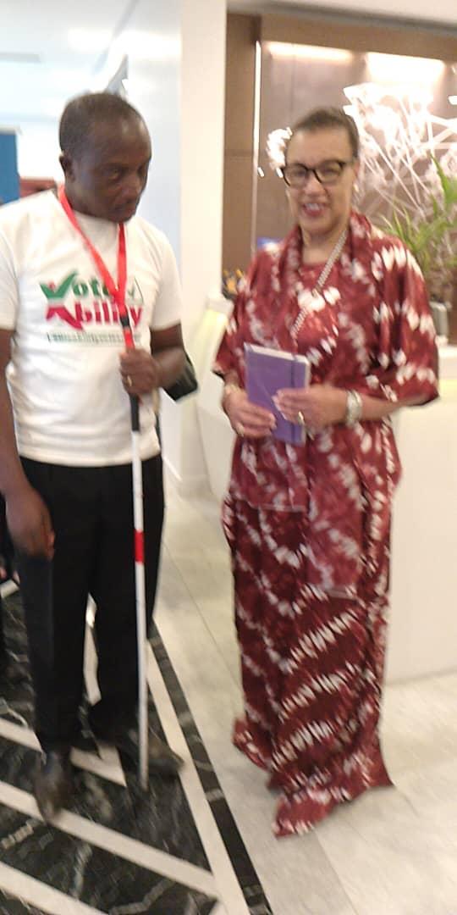
HEAD OF DRELA TEAM WITH BARONESS PATRICIA SCOTLAND, COMMONWEALTH SECRETARY-GENERAL. HEAD OF COMMONWEALTH ELECTION TEAM

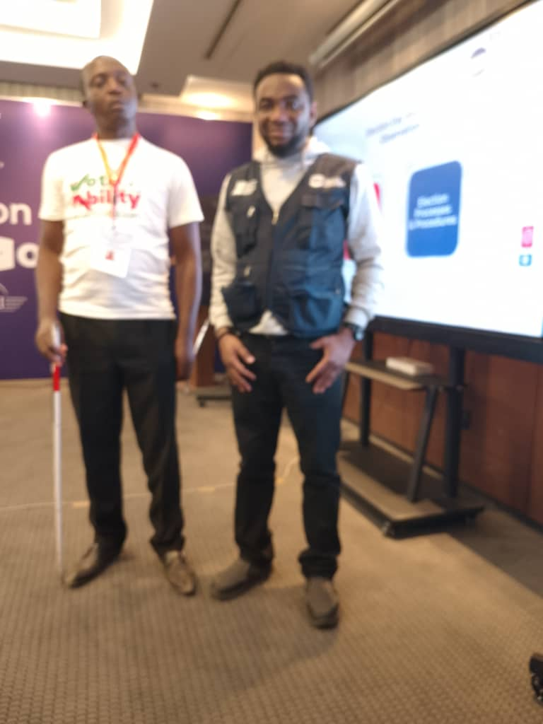
TEAM LEAD, NATIONAL DEMOCRATIC INSTITUTE (IFA ELECTION SITUATION ROOM)
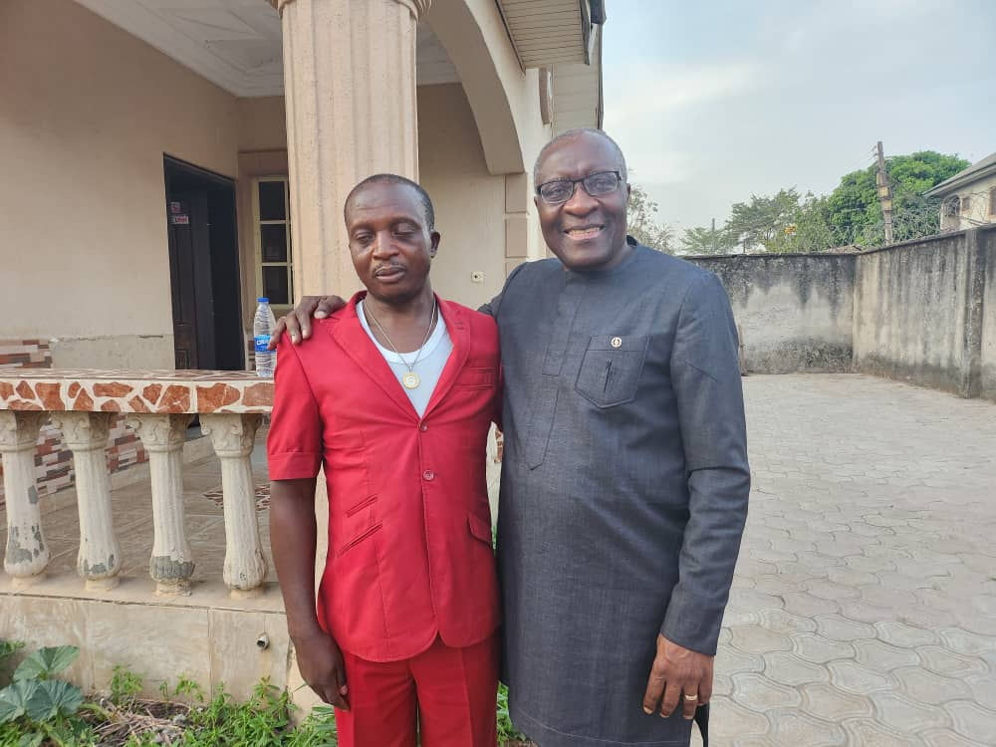
DR CHRISTOPER FOMUNYOH, HEAD OF ELECTION OBSERVATION TEAM, NATIONAL DEMOCRATIC INSTITUTE(NDI) WASHINGTON DC

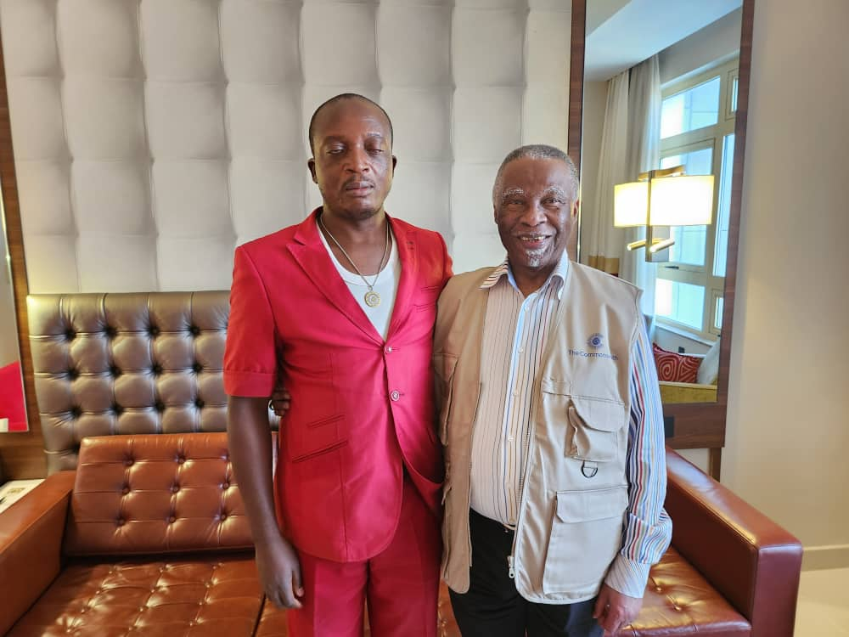
MR THABO MBEKI, FORMER SOUTH AFRICAN PRESIDENT.
HEAD OF ELECTION OBSERVATION TEAM
FORUM OF FORMER AFRICAN PRESIDENTS

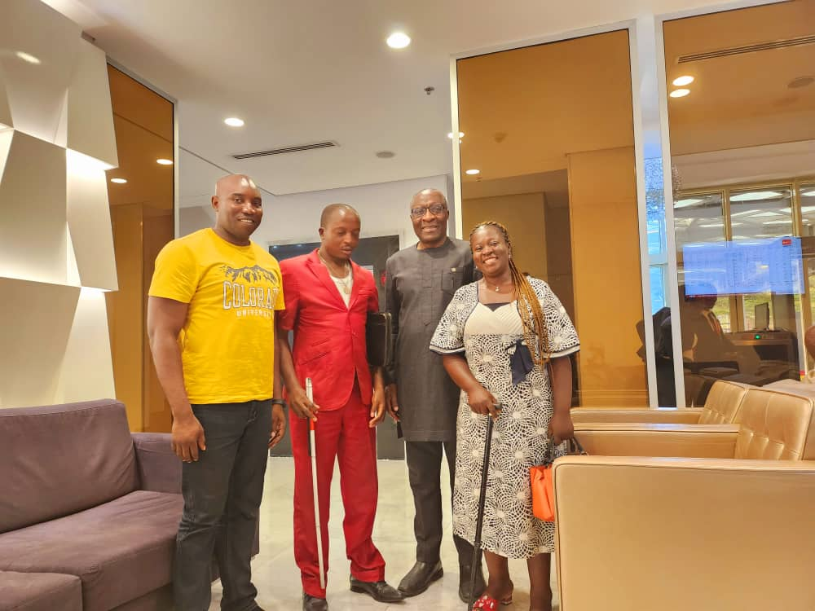
DRELA TEAM, DR CHRISTOPER FOMUNYOH EXECUTIVE DIRECTOR FOR AFRICA, (NDI) AND MR GIMA HUMPHERY, CEO T.Y DANJUMA FOUNDATION

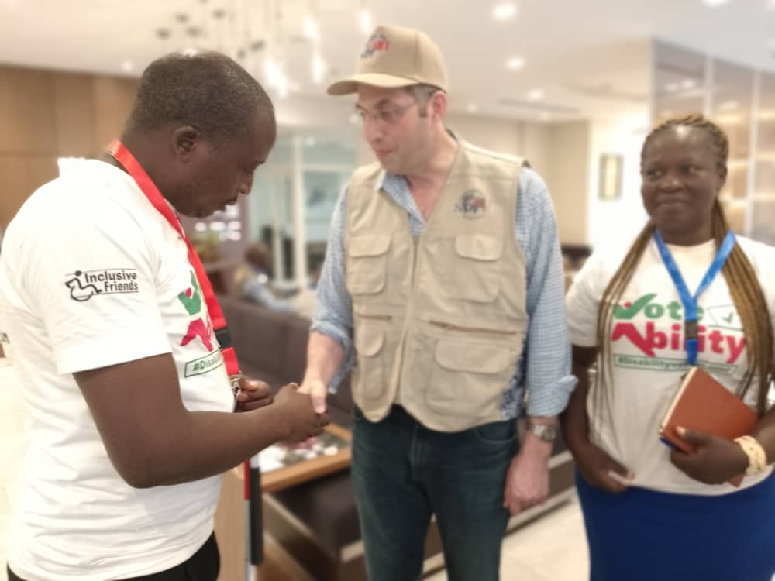
DRELA TEAM WITH MEMBER OF COMMONWEALTH OBSERVATION TEAM

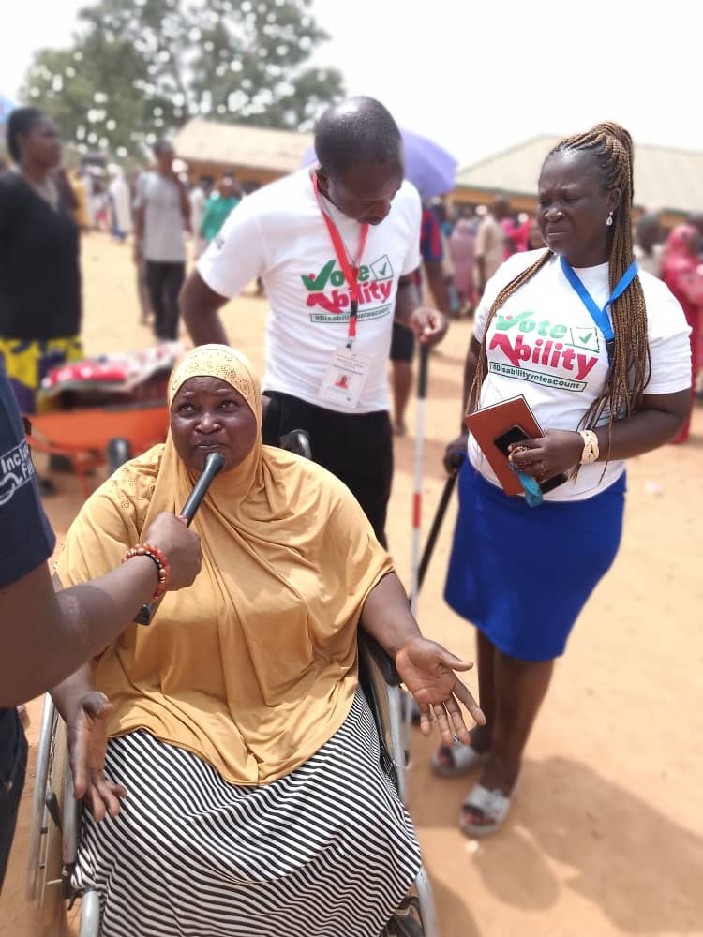
DRELA TEAM INTERVENING FOR PERSONS WITH DISABILITIES(VOTERS)

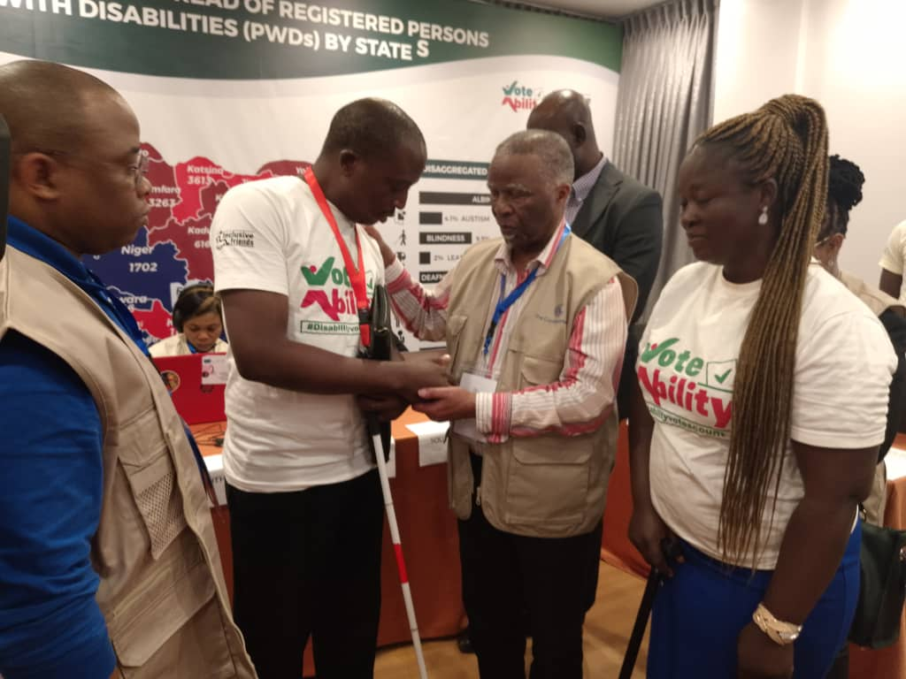
DRELA TEAM WITH MR THABO MBEKI
IFA SITUATION ROOM

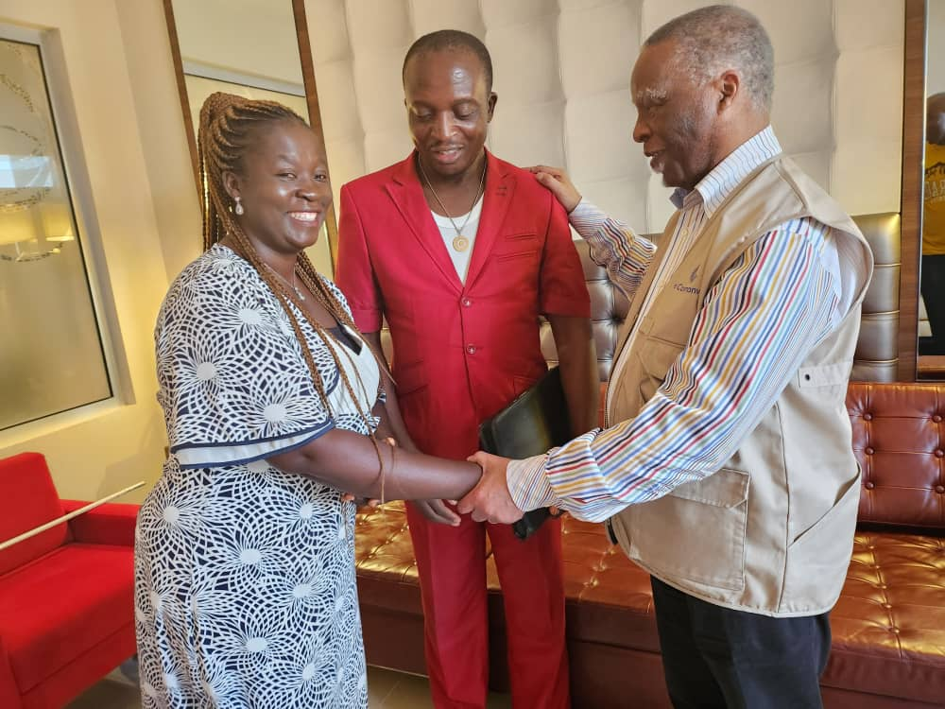
DRELA TEAM WITH MR THABO MBEKI
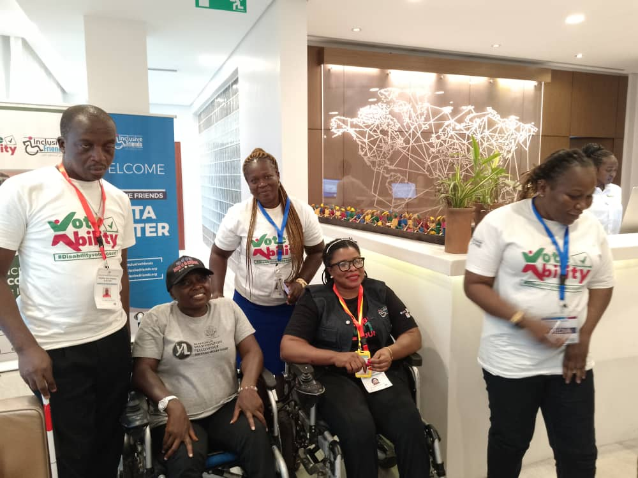
DRELA TEAM WITH MADAM GRACE JERRY, EXECUTIVE DIRECTOR OF INCLUSIVE FRIENDS ASSOCIATION, AND HER TEAM

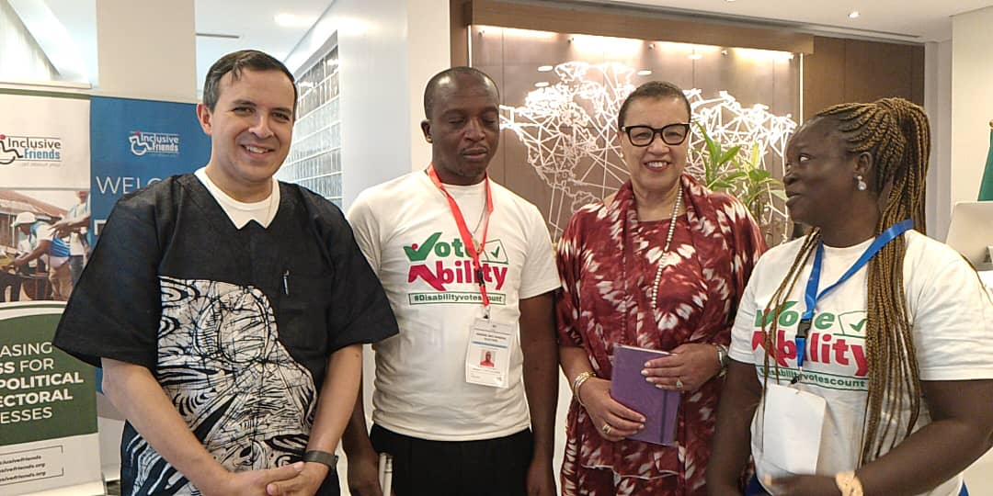
DRELA TEAM WITH COMMONWEALTH TEAM HEADED BY BARONESS PATRICIA SCOTLAND, COMMONWEALTH SECRETARY GENERAL.

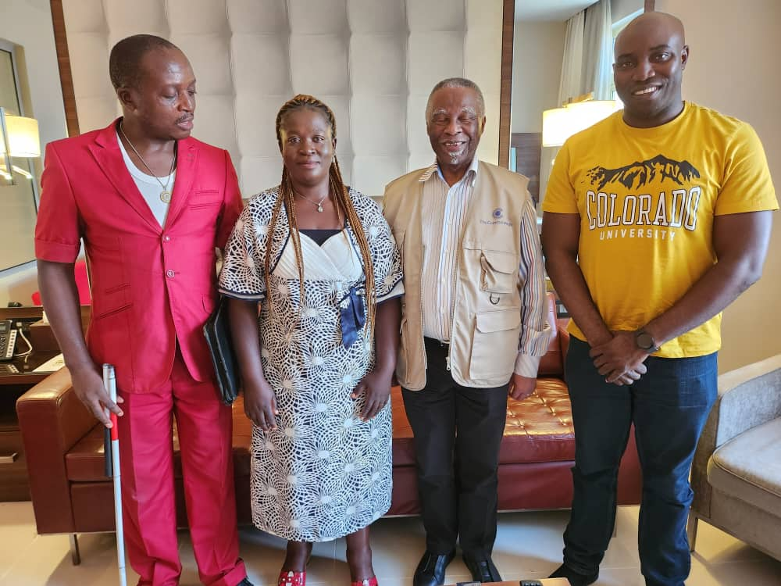
DRELA TEAM WITH MR THABO MBEKI AND MR. GIMA HUMPHERY

